Clinical Case Registries (CCR)
Version 1.5



Installation and Implementation Guide

Documentation Revised August 2014

For Patch ROR*1.5*22

THIS PAGE INTENTIONALLY LEFT BLANK
Revision History
Date | Description | Author | Role
August, 2014 | Final release for Patch ROR*1.5*22. See CCR User Manual for details of enhancements to application. | John Sanders  Terry Kopp  Lori Torrance  Edward Micyus | Project Manager  M Developer  Software Quality Assurance Analyst  Delphi Developer
April, 2014 | Final release for Patch ROR*1.5*21. See CCR User Manual for details of enhancements to application. | John Sanders  Terry Kopp  Lori Torrance  Edward Micyus | Project Manager  M Developer  Software Quality Assurance Analyst  Delphi Developer
March, 2013 | Final release for Patch ROR*1.5*20. See CCR User Manual for details of enhancements to application. | John Sanders  Connie Ray  Steven Baxter  Edward Micyus  Karen Jocius | Project Manager  M Developer  Software Quality Assurance Analyst  Delphi Developer  Tech Writer
August, 2014 | Final release for Patch ROR*1.5*19. See CCR User Manual for details of enhancements to application. | Taraiza Bennett  Dave Getman  Matt Dill /Ferdi Frankson  Brenda Johnson  Jeff Swesky  Ellen Phelps | VA Project Manager  HP Project Manager  M Developer  Software Quality Assurance Analyst  Delphi Developer  Tech Writer
August, 2012 | Final release for Patch ROR*1.5*19. See CCR User Manual for details of enhancements to application. | John Sanders  Connie Ray  Linda Berry  Edward Micyus  Dan Zaudtke | Project Manager  M Developer  Software Quality Assurance Analyst  Delphi Developer  Tech Writer
April, 2012 | Final release for Patch ROR*1.5*17. See CCR User Manual for details of enhancements to application. | John Sanders  Connie Ray  Linda Berry  Edward Micyus  Dan Zaudtke | Project Manager  M Developer  Software Quality Assurance Analyst  Delphi Developer  Tech Writer
September, 2011 | Final release for Patch ROR*1.5*15. See CCR User Manual for details of enhancements to application. | John Sanders  Connie Ray  Linda Berry  Edward Micyus  Dan Zaudtke | Project Manager  M Developer  Software Quality Assurance Analyst  Delphi Developer  Tech Writer
March 2011 | Patch ROR*1.5*14. See CCR User Manual for details of enhancements to application. | Vida Dunie  Angela Saunders  Linda Berry  Ed Micyus | Technical Writer  M Developer  Software Quality Assurance Analyst  Delphi Developer
September, 2010 | Updated for Patch ROR1.5*13. See CCR User Manual for details of changes to application.  Documentation Change only: Previous references to manual data back pulling have been removed. This process is now automated. | Kenneth Rikard  Edward Micyus  Angela Saunders  Linda Berry | Project Manager  Delphi Developer  M Developer  Software Quality Assurance Analyst
April, 2010 | Final release for Patch ROR*1.5*10. Added instructions for data Backpull; general updates per comments received; general formatting changes. | VJ McDonald | Technical Writer

THIS PAGE INTENTIONALLY LEFT BLANK

Table of Contents
1. Introduction 1
1.1 How CCR Works 1
1.2 Recommended Users 1
1.3 Related Documents 1
1.4 Typographical Conventions Used in the Guide 2
1.5 Screen Displays and Text Notes 3
1.6 Software and Manual Retrieval 3
1.7 VistA Documentation on the Intranet 4
2. Installing Current CCR 1.5 4
3. Installing the Current M Patch 5
4. Installing the Graphical User Interface 9
4.1 Background Information 9
4.2 Uninstalling Older Software Versions 10
4.3 Installing New GUI 11
4.4 Configuring Desktop Application Parameters 19
4.5 Command-Line Switches 20
Glossary 23

List of Tables
Table 1 – Typographical Conventions 2
Table 2 – Graphical Conventions 2
Table 3 – Software and Documentation Sources 4
Table 4 – Files Included in Distribution 4
Table 5 – Current CCR 1.5 Patches 6
Table 6 – M Code Installation Instructions 7
Table 7 – Uninstalling Previous GUI Versions 10
Table 8 – Installing New GUI 12
Table 9 – Installing New GUI on a File Server 18
Table 10 – Command Line Switches 21

List of Figures

Figure 1 – Change/Remove or Remove Button 10
Figure 2 – Uninstall Confirmation 11
Figure 3 – Sample Setup Wizard Welcome Screen 12
Figure 4 – Setup Wizard Directory Confirmation 13
Figure 5 – Select Start Menu Folder 14
Figure 6 – Select Additional Tasks 15
Figure 7 – Ready to Install 16
Figure 8 – Installation Confirmation 17
Figure 9 – Configuring Desktop Parameters 20
Figure 10 – Command-Line Switches 21

Introduction
This Clinical Case Registries Installation and Implementation Guide provides assistance for installation and implementation of the Clinical Case Registries (CCR) software.

How CCR Works
CCR software application collects data on the population of veterans with certain clinical conditions, namely Hepatitis C and/or Human Immunodeficiency Virus (HIV) infections at the local and national level as well as 17 local, generic registries. Patients are identified by the existence of a disease-related International Statistical Classification of Diseases and Related Health Problems, ninth edition (ICD-9) code or by a positive result on an antibody test. Such patients are added to the registry in a pending state. Pending patients are reviewed by the local registry coordinator and if the data confirm the diagnosis, the local registry coordinator confirms the patient in the registry.
Each night a background process transmits a set of predefined data via Health Level 7 (HL7) message to the national CCR database at the Corporate Data Center Operations (CDCO). Data from both the Hepatitis C and HIV registries are aggregated in the same message. If there is more new data than is allowed by the registry parameter for a single CCR HL7 batch message (the current limit is 5 megabytes), the software will send several messages during a single night. The CCR software creates a limited set of database elements to be stored locally in the Veterans Health Information Systems and Technology Architecture (VistA ) system, and focuses on assuring that the local listing is complete and accurate, that the desired data elements are extracted, and that data elements are appropriately transmitted to the national database.
Data from the registries is used for both clinical and administrative reporting on both a local and national level. Each facility can produce local reports which show information related to patients seen in their system. Reports from the national database are used to monitor clinical and administrative trends, including issues related to patient safety, quality of care and disease evolution across the national population of patients.

Recommended Users
The Information Resource Management (IRM) staff and CCR Automated Data Processing Application Coordinator (ADPAC) are required for the installation of CCR.

Related Documents
- Clinical Case Registries Release Notes
- Clinical Case Registries Technical Manual/Security Guide
- Clinical Case Registries User Manual

Typographical Conventions Used in the Guide
Fonts and other conventions shown in Table 1 are used throughout this document. Conventions for the use of graphic icons and other symbols are shown in Table 2. Also see Screen Displays and Text Notes for explanations of how computer dialogs are presented.

Table 1 – Typographical Conventions
Font | Used for… | Examples:
Blue text, underlined | Hyperlink to another document or address | ftp.fo-slc.med.va.gov
Green text, dashed underlining | Hyperlink to a place in this document | “CCR accesses several other Veterans Health Information Systems and Technology Architecture (VistA) files…”
Courier New | Patch names | ROR*1.5*2
Courier New | VistA menu options | “On the PackMan menu, use the INSTALL/CHECK MESSAGE option.”
Courier New | VistA filenames | XYZ file #798.1
Courier New | VistA field names | COMMENT field (#12).
Franklin Gothic Demi bold | Keyboard keys and on-screen button text | < F1 >, < Alt >, < L >, < Enter >, [Delete] button
Microsoft Sans Serif | Software Application names | Clinical Case Registries (CCR)
Microsoft Sans Serif | Registry names | CCR:HIV
Microsoft Sans Serif | GUI database field names | Comment field
Microsoft Sans Serif | GUI report names | Procedures report
Microsoft Sans Serif bold | GUI panel, pane, tab, button and command icon names | Other Registries panel
Times New Roman | Normal text | “… designed for use by designated Registry Coordinators, Managers, and Clinicians….”
Times New Roman Italic | Text emphasis | “It is very important…”
Times New Roman Italic | National and International Standard names | International Statistical Classification of Diseases and Related Health Problems
Times New Roman Italic | Document names | Clinical Case Registries User Manual

Table 2 – Graphical Conventions
Graphic | Used for…
 | Information of particular interest regarding the current subject matter
 | A tip or additional information that may be helpful to the user
 | A warning concerning the current subject matter
 | A guide to which action is to be performed next

Screen Displays and Text Notes
In this guide, user responses are shown in bold type, but do not appear on the screen as bold. The bold part of the entry is the letter, or letters, that you must type so that the computer can identify the response. In most cases, you only have to enter the first few letters. This increases speed and accuracy.
In VistA, every response you type must be followed by pressing the < Return > key (or < Enter > for some keyboards). In VistA screen shots, whenever this key should be pressed, you will see the symbol <RET>. This symbol is not shown but is implied if there is bold input.
Within the “roll’n’scroll” part of the system, Help frames may be accessed from most prompts by entering one, two, or three question marks (?, ??, or ???).
Within the examples of actual terminal dialogues, additional information about the dialogue may be shown. This information is enclosed in brackets, for example, {type ward name here}, and it does not appear on the screen.
Computer dialogues appear in Courier font.
Where graphical interface windows are mentioned, and the user is instructed to click an on-screen button, that button will be shown in Franklin Gothic Demi bold font enclosed in square brackets and/or with a graphic symbol. Example: “Click the [Submit] button” or “Click the button.”
All headings and text in this guide are intentionally formatted flush left, regardless of the heading level, to save space and to make for better readability.
In tables which list mandatory steps (as for installation or un-installation), a column is provided at the right-hand side so that users may check () off the step as it is performed.

Software and Manual Retrieval
Both the CCR 1.5 software distributives and documentation files are available for downloading from the following Office of Information Field Offices (OIFO) [ANONYMOUS SOFTWARE] directories.

Table 3 – Software and Documentation Sources
OIFO | FTP Address | Directory
Albany | ftp.fo-albany.med.va.gov | anonymous.software
Hines | ftp.fo-hines.med.va.gov | anonymous.software
Salt Lake City | ftp.fo-slc.med.va.gov | anonymous.software

The ROR*1.5*22 (CCR 1.5.22) software and accompanying guides and manuals are distributed as the set of files shown in Table 4. No distribution is being made for the original CCR 1.5 versions. Since some sites may need to access both sets of documents during an interim period, the original CCR 1.5 versions of the documentation will remain available on the VistA Document Library (VDL) at http://www.va.gov/vdl/application.asp?appid=126.

Table 4 – Files Included in Distribution
File Name | Contents | Retrieval Format
ROR1_5P22GUI.ZIP | Zipped GUI distributive  ► CCRSETUP.EXE | BINARY
ROR1_5P22DOC1.ZIP | Zipped DOC distributive, which includes both .PDF and .DOC formats:  ► User Manual (ROR1_5_22UM) | BINARY
ROR1_5P22DOC2.ZIP | ► Installation and Implementation Guide (ROR1_5_22IG)  ► Technical Manual / Security Guide (ROR1_5_22TM)  ► Release Notes (ROR1_5_22RN) | BINARY

VistA Documentation on the Intranet
Documentation for this product, including all of the software manuals, is available in the VDL. Clinical Case Registries documentation may be found at http://www.va.gov/vdl/application.asp?appid=126.
For additional information about the CCR, access the CCR Home Page at the following address: http://VistA.med.va.gov/ClinicalSpecialties/CCR/.
Training links and information are also available at http://vaww.VistAu.med.va.gov/VistAu/CCR/.

Installing Current CCR 1.5

Important Note: This patch requires an M patch and a revised Graphical User Interface (GUI) application.

Installing CCR 1.5 current version is a two-step process:
- Installing the Current M Patch
- Installing the Graphical User Interface

Note: The M routines included in KIDS build ROR 1.5 are listed in the CCR Technical Manual. The second line of each of these routines now looks like:

;;1.5;CLINICAL CASE REGISTRIES;**[Patch List]**;Feb 17, 2006;Build [NN]

Installing the Current M Patch
All CCR patches are available via the National Patch Tracking module in FORUM. All patches contain installation instructions and must be installed in sequence number order. Current patches to CCR 1.5 are listed in Table 5. Please be sure that all previous patches are installed before attempting to install the latest patch. Note that the latest patch is shown at the top of the table.

Table 5 – Current CCR 1.5 Patches
Patches | Description | 
ROR*1.5*22 | 6 enhancements and 2 modifications. See CCR Release Notes.
ROR*1.5*21 | 10 enhancements. See CCR Release Notes.
ROR*1.5*20 | 1 enhancement. See CCR Release Notes.
ROR*1.5*19 | 6 enhancements and 2 modifications. See CCR Release Notes.
ROR*1.5*18 | 8 enhancements, 7 modifications and 1 fixes. See CCR Release Notes.
ROR*1.5*17 | 5 enhancements, 3 modifications and 3 fixes. See CCR Release Notes.
ROR*1.5*15 | 9 enhancements, 5 modifications and 2 fixes. See CCR Release Notes.
ROR*1.5*14 | 10 enhancements. See CCR Release Notes.
ROR*1.5*13 | 1 modification; 1 fix; 8 enhancements. See CCR Release Notes.
ROR*1.5*10 | 5 modifications; 2 fixes; 11 enhancements. See CCR Technical Manual.
ROR*1.5*9 | Maintenance bug fixes
ROR*1.5*8 | 1 fix; 9 enhancements. See CCR Technical Manual.
ROR*1.5*7 | 1 enhancement: Added generic drug ETRAVIRINE to VA GENERIC file #50.6.
ROR*1.5*6 | 1 enhancement: Added generic drug RALTEGRAVIR to VA GENERIC file #50.6.
ROR*1.5*5 | 1 fix: Resolved issue with Procedures w/o Provider not being sent to AAC.  1 enhancement: Added drug needed for nightly registry update and data extraction.
ROR*1.5*4 | 1 enhancement: Added two ICD-9 codes.
ROR*1.5*3 | 2 enhancements: Added Reason for Study data field; added task Control flag.
ROR*1.5*2 | 7 fixes: See CCR Technical Manual
ROR*1.5*1 | 14 enhancements: See CCR Technical Manual

Below is a summary of the steps required to install this patch; installation will not take more than five minutes.
This patch can be installed with VistA users online, but Registry users should be logged out of the CCR Registry Application, as a new GUI is to be installed.

Important Note: The nightly task (the [ROR TASK] option) must not be running during the installation.

Important Note: TaskMan does not need to be STOPPED or placed in a WAIT state.

Table 6 – M Code Installation Instructions
Step # | Description |  | 
1 | Check the user who scheduled the nightly job, ROR TASK. The task must  be scheduled by an active user with the ROR VA IRM security key. If the  user has been terminated or no longer has the key, make sure the job is  removed and re-scheduled by a qualified user.
2 | Make sure you have the ROR VA IRM security key.
3 | On the PackMan menu, use the INSTALL/CHECK MESSAGE option. This option loads the patch into a Transport Global on your system.
4 | From the Kernel Installation and Distribution System (KIDS) menu, select the Installation menu.
5 | From this menu, you may elect to use the following options (when prompted for INSTALL NAME, enter ROR*1.5*22):
 | a | Verify Checksums in Transport Global: This option will allow you to ensure the integrity of the routines that are in the transport global. Routines are listed in the CCR Technical Manual.
 | b | Print Transport Global: This option will allow you to view the components of the KIDS build.
 | c | Compare Transport Global to Current System: This option will allow you to view all changes that will be made when this patch is installed. It compares all components of this patch (routines, Data Dictionaries (DD's), templates, etc.).
 | d | Backup a Transport Global: This option will create a backup message of any routines exported with this patch. It will not backup any other changes such as DD's or templates.
6 | The post-initialization routine for this patch performs the following functions:  - Updates all existing local registry International Classification of Diseases, Ninth Revision (ICD-9) selection rules with the ICD-9 coding system flag.  - Adds the appropriate ICD-10 codes to each local registry.  - Adds the new ICD-10 codes to the records in the ROR ICD SEARCH file (#798.5).  - Creates new selection rules for all local registries  using ICD-10 codes.  - Updates the local registries with the new ICD-10 selection rules.  Use the Install Package(s) option and select the package ROR*1.5*22. The following will display:  Checking Install for Package ROR*1.5*22  Install Questions for ROR*1.5*22  Incoming Files:  798.2 ROR SELECTION RULE (including data)  Note: You already have the 'ROR SELECTION RULE' File.  I will MERGE your data with mine.  799.31 ROR XML ITEM (including data)  Note: You already have the 'ROR XML ITEM' File.  I will OVERWRITE your data with mine.  799.34 ROR REPORT PARAMETERS (including data)  Note: You already have the 'ROR XML ITEM' File.  I will OVERWRITE your data with mine.  799.51 ROR GENERIC DRUG (including data)  Note: You already have the 'ROR GENERIC DRUG' File.  I will OVERWRITE your data with mine.
7 | When prompted 'Want KIDS to INHIBIT LOGONs during the install? NO//', respond "NO".
8 | When prompted 'Want to DISABLE Scheduled Options, Menu Options, and Protocols? NO//', respond "NO".
9 | Enter the Device you want to print the Install message.  You can queue the install by enter a 'Q' at the device prompt.  Enter a '^' to abort the install.

GO TO: Installing the Graphical User Interface

Installing the Graphical User Interface

Background Information
- The current CCR Graphical User Interface (GUI) provides access to both Hepatitis C and HIV registries.
- It is strongly recommended that the CCR GUI be installed on a file server and the CCR application be made available to the CCR users via the Computerized Patient Record System (CPRS) Tool menu. Installing the CCR GUI on workstations is not recommended.
- Access to the registries is controlled by the security keys within VistA.
- For users who have access to a single registry, its window will be opened automatically by the GUI. Users who have access to both registries will be able to select a registry from a list.
- The GUI supports the /NOCCOW command-line parameter that completely disables the CCOW functionality. It also supports the parameter /CCOW=PatientOnly, which disables only the Single Sign-On/User Context (SSO/UC) functionality.

Uninstalling Older Software Versions
If you are doing a first-time installation: There should not be any old software to be uninstalled. If you don’t know whether old software is present, use the uninstall procedure in Table 7 just to be sure! If you are certain that no previous GUI software has been installed, you may skip to section 4.3 11.

If you are doing an upgrade: To eliminate any chance for errors, it is strongly recommended that any older versions be uninstalled using the instructions in Table 7.

Table 7 – Uninstalling Previous GUI Versions
Step # | Description | 
1 | From the Start menu, select Settings, then Control Panel.
2 |  Double-click the Add or Remove Programs icon. If you are not using Windows XP or Windows 7, the icon you see may vary.  The Add or Remove Programs dialog appears:  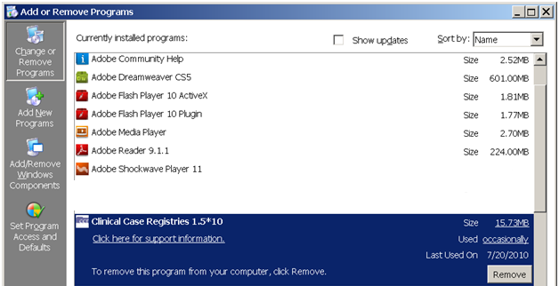  Figure 1 – Change/Remove or Remove Button
2a | Look for any entries that include Clinical Case Registries 1.5* (or simply 1.5*) on the program list. If neither of these appears on the program list, skip to Step 9.  Note that releases of the GUI up until 1/13/2010 were shown simply as “1.5.xx” on the program list; following installation of the 1/13/2010 version, it will correctly display on the list as “Clinical Case Registries 1.5.xx.”  Select Clinical Case Registries from the list and click the [Change/Remove] or [Remove] button.
3 | If prompted, click the [Next] button.
4 | You will likely see a pop-up, asking you to confirm removal:  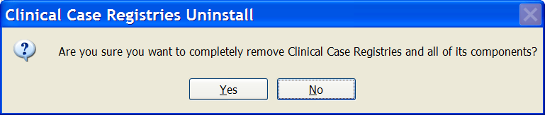  Figure 2 – Uninstall Confirmation
5 |  Confirm the uninstall action by clicking the [Yes] or [OK] button.
6 | Confirm deletion of read-only files by clicking the [Yes] button.
7 | Confirm deletion of shared files by clicking the [Yes] button.
8 | Wait until the Uninstall Wizard completes the removal and then click the [Finish] button.
9 | Look for Hepatitis C Local Registry on the program list. If this does not appear on the program list, skip to Step 13.
10 | Select Hepatitis C Local Registry from the list and click the [Change/Remove] or [Remove] button.
11 | Confirm the uninstall action by clicking the [Yes] or [OK] button.
12 | - Wait until the Uninstall Wizard completes the removal and click the [OK] button.
13 | Close the Add or Remove Programs window and the Control Panel window.

Installing New GUI
Download (see above) and install the new GUI using the instructions in Table 8.

Table 8 – Installing New GUI
Step # | Description | 
1 | Download and unzip the ROR1_5P22GUI.ZIP into a temporary directory.
2 | Open the temporary directory and run (double-click) CCRSetup.exe to begin the installation.
3 | Wait until the setup wizard prepares the setup procedure. A welcome message similar to the one in Figure 3 displays (see note below):  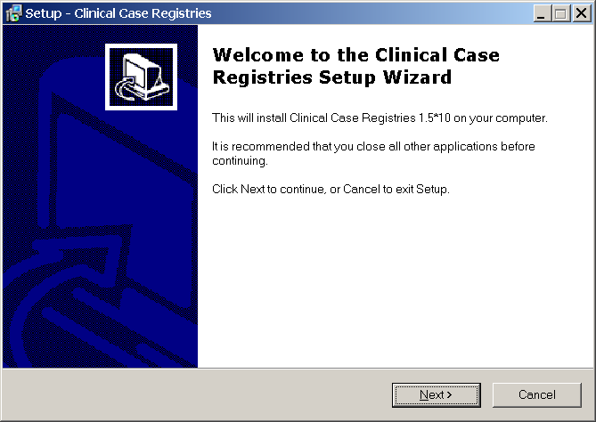  Figure 3 – Sample Setup Wizard Welcome Screen  NOTE: The welcome screen you see should show the patch being installed. In the example in Figure 3, patch 1.5*10 is being installed.
4 | Click [Next] to continue the installation.  The Select Destination Location dialog displays:  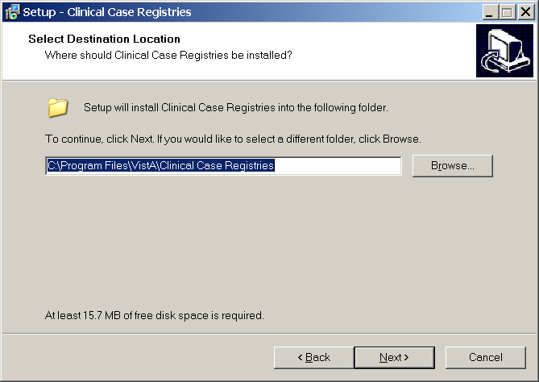  Figure 4 – Setup Wizard Directory Confirmation
5 | Select the directory in which to install the CCR GUI. We recommend that you accept the default directory: C:\Program Files\VistA\Clinical Case Registries\ if you are installing on a user workstation.  To select a different location, click [Browse…] and select the directory.  Click [Next] to continue the installation.  The Select Start Menu Folder dialog displays:  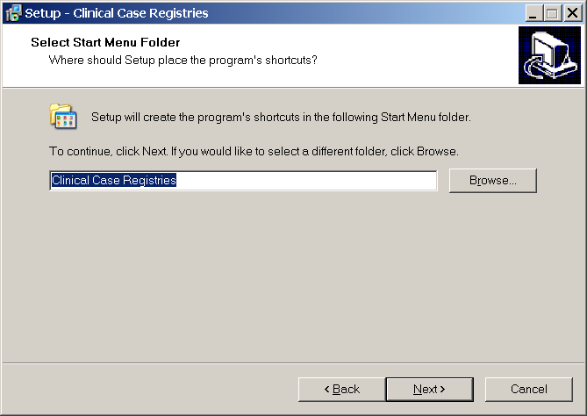  Figure 5 – Select Start Menu Folder
6 | We recommend that you accept the default directory: Clinical Case Registries.  To select a different location, click [Browse…] and select the directory.  Click [Next] to continue the installation.
6 | The Select Additional Tasks dialog appears:  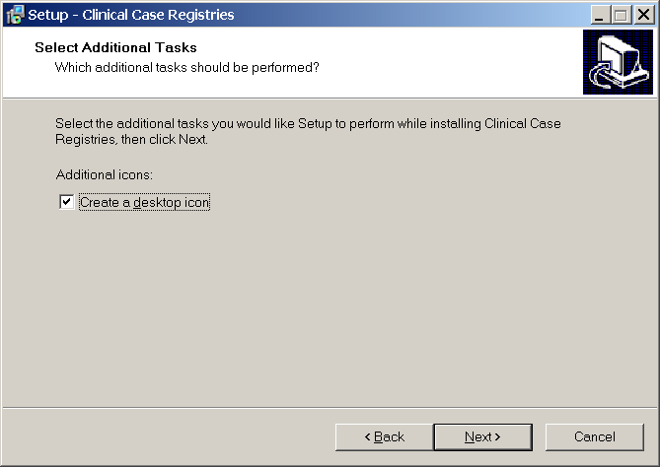  Figure 6 – Select Additional Tasks
7 | If you want a desktop icon, leave the checkbox checked; otherwise, clear the checkbox.  Click [Next] to continue the installation.  The Ready to Install dialog displays:  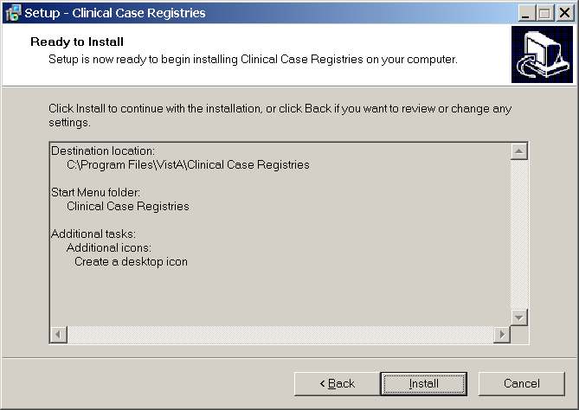  Figure 7 – Ready to Install
8 | Review the installation settings and click [Install] to proceed.  The Wizard finishes the installation and a confirmation screen displays:
8 | 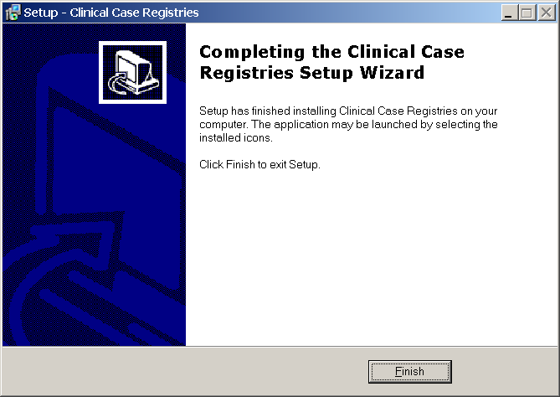  Figure 8 – Installation Confirmation
9 | Click [Finish].

If you installed the CCR GUI on a file server (recommended):
Continue with Table 9 immediately below.
If you installed the CCR GUI on user workstations (not recommended):
Continue with 4.4 19.

Table 9 – Installing New GUI on a File Server
Step # | Description | 
10 | If you installed the CCR GUI on a file server (recommended):  Add the corresponding item to the CPRS Tool menu using the CPRS GUI Tools Menu [ORW TOOL MENU ITEMS] option.  It is recommended that you add the item at “User” level.  If you used the default directory for the installation, the “Name=Command” parameter should look like this:  Clinical Case Registries="C:\Program Files\VistA\Clinical Case Registries\ClinicalCaseRegistries.exe" /S="{Server IP Address}" /P={RPC Broker Port}  Below is a typical configuration example:
  Note: If you have previously set up the CPRS Tools menu (as for a previous version of CCR), you should not have to perform this step. Go to the End Note on page 22.
10 | >D ^XUP  Setting up programmer environment  Terminal Type set to: C-VT320  Select OPTION NAME: ORW TOOL MENU ITEMS  CPRS GUI Tools Menu may be set for the following:  1 User USR [choose from NEW PERSON]  2 Location LOC [choose from HOSPITAL LOCATION]  2.5 Service SRV [choose from SERVICE/SECTION]  3 Division DIV [HINES DEVELOPMENT]  4 System SYS [DEV.DEV.FO-HINES.MED.VA.GOV]  9 Package PKG [ORDER ENTRY/RESULTS REPORTING]  Enter selection: 1  Select NEW PERSON NAME: CCRUSER,ONE  ------ Setting CPRS GUI Tools Menu for User: CCRUSER,ONE -------  Select Sequence: 10  Are you adding 10 as a new Sequence? Yes// <RET>  Sequence: 10// <RET>  Name=Command: Clinical Case Registries="C:\Program Files\VistA\Clinical Case Registries\ClinicalCaseRegistries.exe" /S="10.3.29.201" /P=9200  Select Sequence: <RET>
10 | Please refer to the GUI Tool Menu Items section of the Computerized Patient Record System (CPRS) v1.0 Setup Guide (http://www.va.gov/vdl/application.asp?appid=61) for more details.  You can also use other command-line parameters described in below to further customize the menu item (limit access to a single registry, disable CCOW, etc.).

Configuring Desktop Application Parameters

Note: Follow these instructions only if you elected to install the GUI on user workstations (not recommended).

There are two ways to configure the GUI for those users who are coordinators of both Hepatitis C and HIV registries:
- Single shortcut: This is the default. A single shortcut is created on the desktop. When the GUI is launched (or when File, Open is selected from the menu), the user selects the desired registry from the list.
- Separate shortcuts: Two separate shortcuts are created, one for the Hepatitis C registry and one for the HIV registry. A command-line switch in each shortcut allows access only to a single registry. As a result, the registry selection dialog box is not displayed and the corresponding registry is opened automatically. This can be accomplished by adding the /R parameter after the executable name in the Target field of the shortcut. For example:
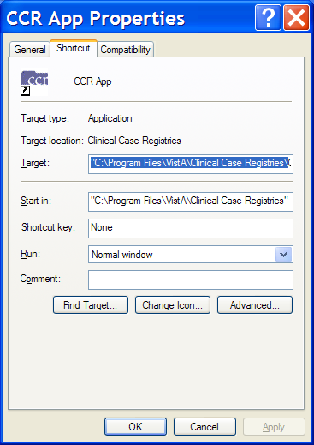
Figure 9 – Configuring Desktop Parameters

The Target field should read…
"C:\Program Files\VistA\Clinical Case Registries\ClinicalCaseRegistries.exe" /R="VA HEPC"

Command-Line Switches
You can get a list of command-line “switches” supported by the CCR GUI by running the application with the /? or /h parameter. For example:

Start | Run | "C:\Program Files\VistA\Clinical Case Registries\ClinicalCaseRegistries. exe" /?

Note the use of quotation marks around the “target” application name. These are required when using this method because the C:\Program Files\Vista directory is typically not in the path (the list of directories which the operating system searches for executable files).

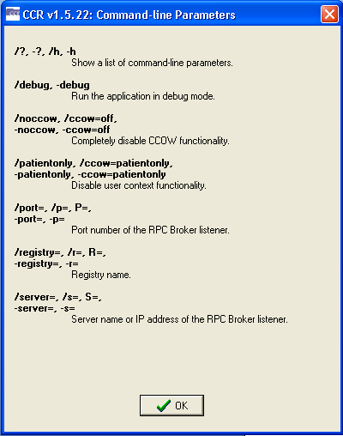
Figure 10 – Command-Line Switches

The switches are also shown in Table 10 for convenience.

Table 10 – Command Line Switches
Switch | Description
/?, -?, /h, -h | Show a list of command-line parameters
/debug, -debug | Run the application in debug mode
/noccow, /ccow=off,  -noccow, -ccow=off | Completely disable CCOW functionality
/patientonly, /ccow=patientonly,  -patientonly,  -ccow=patientonly | Disable user context functionality
/port=, /p=, P=,  -port=, -p= | Port number of the Remote Procedure Call Broker (RPC) listener
/registry=, /r=, R=,  -registry=, -r= | Registry name
/server=, /r=, S=,  -server=, -s= | Server name or IP address of the RPC Broker listener

Upgrading/installation and implementation are complete. Check documentation for further details. If you have not already downloaded the documentation files, see 1.6 Software and Manual Retrieval 3.
You may also find the documentation on the VistA Documentation Library (VDL) at http://www.va.gov/vdl/application.asp?appid=126.

Glossary
A more complete glossary is included in the CCR User Manual.

Term or Acronym | Description
AAC | See Austin Automation Center
Acquired Immunodeficiency Syndrome (AIDS) | AIDS is a disease of the human immune system caused by the human immunodeficiency virus (HIV). This condition progressively reduces the effectiveness of the immune system and leaves individuals susceptible to opportunistic infections and tumors.
API | See Application Programmer Interface
ADPAC | See Automated Data Processing Application Coordinator
AIDS | See Acquired Immunodeficiency Syndrome
AITC | See Austin Information Technology Center
Application Program Interface (API) | The interface (calling conventions) by which an application program accesses operating system and other services. An API is defined at source code level and provides a level of abstraction between the application and the kernel (or other privileged utilities) to ensure the portability of the code.  An API can also provide an interface between a high level language and lower level utilities and services which were written without consideration for the calling conventions supported by compiled languages. In this case, the API's main task may be the translation of parameter lists from one format to another and the interpretation of call-by-value and call-by-reference arguments in one or both directions.
Austin Automation Center (AAC) | See Corporate Data Center Operations
Austin Information Technology Center (AITC) | See Corporate Data Center Operations
Automated Data Processing Application Coordinator (ADPAC) | The ADPAC is the person responsible for planning and implementing new work methods and technology for employees throughout a medical center. ADPACs train employees and assist users when they run into difficulties, and needs to know how all components of the system work. ADPACs maintain open communication with their supervisors and Service Chiefs, as well as their counterparts in Fiscal and Acquisitions and Materiel Management (A&MM), or Information Resource Management (IRM).
CCOW | See Clinical Context Object Workgroup
Clinical Context Object Workgroup (CCOW) | CCOW is an HL7 standard protocol designed to enable disparate applications to synchronize in real-time, and at the user-interface level. It is vendor independent and allows applications to present information at the desktop and/or portal level in a unified way.  CCOW is the primary standard protocol in healthcare to facilitate a process called "Context Management." Context Management is the process of using particular "subjects" of interest (e.g., user, patient, clinical encounter, charge item, etc.) to 'virtually' link disparate applications so that the end-user sees them operate in a unified, cohesive way.  Context Management can be utilized for both CCOW and non-CCOW compliant applications. The CCOW standard exists to facilitate a more robust, and near "plug-and-play" interoperability across disparate applications.  Context Management is often combined with Single Sign-On applications in the healthcare environment, but the two are discrete functions. Single Sign On is the process that enables the secure access of disparate applications by a user through use of a single authenticated identifier and password.
Computerized Patient Record System (CPRS) | A Computerized Patient Record (CPR) is a comprehensive database system used to store and access patients’ healthcare information. CPRS is the Department of Veteran’s Affairs electronic health record software. The CPRS organizes and presents all relevant data on a patient in a way that directly supports clinical decision making. This data includes medical history and conditions, problems and diagnoses, diagnostic and therapeutic procedures and interventions. Both a graphical user interface version and a character-based interface version are available. CPRS provides a single interface for health care providers to review and update a patient’s medical record, and to place orders, including medications, special procedures, x-rays, patient care nursing orders, diets, and laboratory tests. CPRS is flexible enough to be implemented in a wide variety of settings for a broad spectrum of health care workers, and provides a consistent, event-driven, Windows-style interface.
Corporate Data Center Operations (CDCO) | Federal data center within the Department of Veterans Affairs (VA). As a franchise fund, or fee-for-service organization, CDCO-Austin provides cost-efficient IT enterprise solutions to support the information technology needs of customers within the Federal sector. Formerly the Austin Automation Center (AAC); formerly the Austin Information Technology Center (AITC).  See http://www.cdco.va.gov/.
CPRS | See Computerized Patient Record System
DBIA | See Database Integration Agreement
DFN | File Number—the local/facility patient record number (patient file internal entry number)
Database Integration Agreement (DBIA) | M code is not “compiled and linked,” so any code is open to anyone to call. The same is true for the data. This permits an incredible level of integration between applications, but it is “too open” for some software architects' liking. The VA has instituted Database Integration Agreements to enforce external policies and procedures to avoid unwanted dependencies.
Data Extraction Process | This process is run after the registry update process. This function goes through patients on the local registry and, depending on their status, extracts all available data for the patient, since the last extract was run. The extract transmits any collected data for the patient to the national database via HL7.
FileMan | FileMan is a set of M utilities written in the late 1970s and early 1980s which allow the definition of data structures, menus and security, reports, and forms.  Its first use was in the development of medical applications for the Veterans Administration (now the Department of Veterans Affairs). Since it was a work created by the government, the source code cannot be copyrighted, placing that code in the public domain. For this reason, it has been used for rapid development of applications across a number of organizations, including commercial products.
FORUM | FORUM is the VA’s national-scale email system. FORUM uses the VistA mail software and provides an excellent interface for threaded messages that can take the form on ongoing discussions. The national patch module is a VistA application that helps developers to manage the numbering, inventory, and release of patches. Patches are developed in response to request submissions and an error reporting request system known as National Online Information Sharing. A process called the Kernel Installation Distribution System (KIDS) is used to roll up patches into text messages that can be sent to sites along with installation instructions. The patch builds are sent as text messages via email, and the recipient (e.g., a site administrator) can run a PackMan function to unpack the KIDS build and install the selected routines.  See http://citeseerx.ist.psu.edu/viewdoc/download?doi=10.1.1.100.5551&rep=rep1&type=pdf
Globals | M globals are variables which are intrinsically stored in files and persist beyond the program or process completion. Globals appear as normal variables with the caret character in front of the name. For example, the M statement…  SET ^A(“first_name”)=”Bob”  …will result in a new record being created and inserted in the file structure, persistent just as a file persists in an operating system. Globals are stored, naturally, in highly structured data files by the language and accessed only as M globals. Huge databases grow randomly rather than in a forced serial order, and the strength and efficiency of M is based on its ability to handle all this flawlessly and invisibly to the programmer.  For all of these reasons, one of the most common M programs is a database management system. FileMan is one such example. M allows the programmer much wider control of the data; there is no requirement to fit the data into square boxes of rows and columns.
Graphical User Interface (GUI) | A graphical user interface (or GUI, often pronounced “gooey”) is a graphical (rather than purely textual) user interface to a computer. A GUI is a particular case of user interface for interacting with a computer which employs graphical images and widgets in addition to text to represent the information and actions available to the user. Usually the actions are performed through direct manipulation of the graphical elements. A GUI takes advantage of the computer’s graphics capabilities to make the program easier to use.  Sources:  http://en.wikipedia.org/wiki/GUI  http://www.webopedia.com/TERM/G/Graphical_User_Interface_GUI.html  See also User Interface
GUI | See Graphical User Interface
Health Level 7 (HL7) | One of several American National Standards Institute (ANSI)–accredited Standards Developing Organizations operating in the healthcare arena. "Level Seven" refers to the highest level of the International Standards Organization's (ISO) communications model for Open Systems Interconnection (OSI)— the application level. The application level addresses definition of the data to be exchanged, the timing of the interchange, and the communication of certain errors to the application. The seventh level supports such functions as security checks, participant identification, availability checks, exchange mechanism negotiations and, most importantly, data exchange structuring. HL7 focuses on the interface requirements of the entire health care organization. Source: http://www.hl7.org/about/.
Hepatitis C | A liver disease caused by the hepatitis C virus (HCV). HCV infection sometimes results in an acute illness, but most often becomes a chronic condition that can lead to cirrhosis of the liver and liver cancer.  See http://www.cdc.gov/hepatitis/index.htm
HIV | See Human Immunodeficiency Virus
HL7 | See Health Level 7
Human Immunodeficiency Virus (HIV) | HIV is a lentivirus (a member of the retrovirus family) that can lead to acquired immunodeficiency syndrome (AIDS), a condition in humans in which the immune system begins to fail, leading to life-threatening opportunistic infections. HIV is different from most other viruses because it attacks the immune system. The immune system gives our bodies the ability to fight infections. HIV finds and destroys a type of white blood cell (T cells or CD4 cells) that the immune system must have to fight disease.  See also AIDS.  See http://www.cdc.gov/hiv/topics/basic/index.htm.
ICD-9 | See International Statistical Classification of Diseases and Related Health Problems, ninth edition
Information Resources Management (IRM) | The service which is involved in planning, budgeting, procurement and management-in-use of VA's information technology investments.
Interface | An interface defines the communication boundary between two entities, such as a piece of software, a hardware device, or a user.
International Statistical Classification of Diseases and Related Health Problems, ninth edition (ICD-9) | The ninth edition provides numeric codes to classify diseases and a wide variety of signs, symptoms, abnormal findings, complaints, social circumstances and external causes of injury or disease. Every health condition can be assigned to a unique category and given a code, up to six characters long. Such categories can include a set of similar diseases. The “-9” refers to the ninth edition of these codes; the tenth edition has been published, but is not in widespread use at this time.
IRM | See Information Resource Management
Kernel | The VistA software that enables VistA applications to coexist in a standard operating system independent computing environment.
Kernel Installation and Distribution System (KIDS) | KIDS provides a mechanism to create a distribution of packages and patches; allows distribution via a MailMan message or a host file; and allows queuing the installation of a distribution for off-hours.
KIDS | See Kernel Installation and Distribution System
Library | In programming, a library is a collection of precompiled routines that a program can use. The routines, sometimes called modules, are stored in object format. Libraries are particularly useful for storing frequently used routines because you do not need to explicitly link them to every program that uses them. The linker automatically looks in libraries for routines that it does not find elsewhere.
Local Registry | The local file of patients that have either passed the selection rules (and therefore been added automatically), or that have been added manually by a designated ICR supervisor.
Logical Observation Identifiers Names and Codes (LOINC) | The LOINC database was developed to provide a definitive standard for identifying clinical information in electronic reports. The LOINC database provides a set of universal names and ID codes for identifying laboratory and clinical test results in the context of existing HL7 and other observation report messages.
LOINC | See Logical Observation Identifiers Names and Codes
M | M is a procedural, interpreted, multi-user, general-purpose programming language designed to build and control massive databases. It provides a simple abstraction that all data values are strings of characters, and that all data can be structured as multiple dimensional arrays. M data structures are sparse, using strings of characters as subscripts.  M was formerly (and is still commonly) called MUMPS, for Massachusetts General Hospital Utility Multiprogramming System.
MUMPS | See M
Namespace | A logical partition on a physical device that contains all the artifacts for a complete M system, including globals, routines, and libraries. Each namespace is unique, but data can be shared between namespaces with proper addressing within the routines. In VistA, namespaces are usually dedicated to a particular function. The ROR namespace, for example, is designed for use by CCR.
National Case Registry | All sites running the ICR registry transmit their data to this central data registry.
Remote Procedure Call (RPC) | A type of protocol that allows one program to request a service from a program located on another computer network. Using RPC, a system developer need not develop specific procedures for the server. The client program sends a message to the server with appropriate arguments and the server returns a message containing the results of the program executed. In this case, the GUI client uses an RPC to log the user on to VistA. And to call up, and make changes to, data that resides on a VistA server.  See also Remote Procedure Call (RPC) Broker
Remote Procedure Call (RPC) Broker | A piece of middleware software that allows programmers to make program calls from one computer to another, via a network. The RPC Broker establishes a common and consistent foundation for client/server applications being written under the VistA umbrella. The RPC Broker acts as a bridge connecting the client application front-end on the workstation (in this case, the Delphi Query Tool application) to the M –based data and business rules on the server. It serves as the communications medium for messaging between VistA client/server applications. Upon receipt, the message is decoded, the requested remote procedure call is activated, and the results are returned to the calling application. Thus, the RPC Broker helps bridge the gap between the traditionally proprietary VA software and other types of software.  See also Remote Procedure Call (RPC)
Routine | A section of a software program that performs a particular task. Programs consist of modules, each of which contains one or more routines. The term routine is essentially synonymous with procedure, function, and subroutine.
RPC | See Remote Procedure Call (RPC)
RPC Broker | See Remote Procedure Call Broker
Security Keys | Codes which define the characteristic(s), authorization(s), or privilege(s) of a specific user or a defined group of users. The VistA option file refers to the security key as a “lock.” Only those individuals assigned that “lock” can use a particular VistA option or perform a specific task that is associated with that security key/lock.
Single Sign On | Single Sign On is the process that enables the secure access of disparate applications by a user through use of a single authenticated identifier and password.
Technical Services Project Repository (TSPR) | The TSPR is the central data repository and database for VA Health IT (VHIT) project information.  See http://tspr.VistA.med.va.gov/tspr/default.htm
TSPR | See Technical Services Project Repository
User Interface | A user interface is the means by which people (the users) interact with a particular machine, device, computer program or other complex tool (the system). The user interface provides one or more means of:  • Input, which allows the users to manipulate the system  • Output, which allows the system to produce the effects of the users’ manipulation  The interface may be based strictly on text (as in the traditional “roll and scroll” IFCAP interface), or on both text and graphics.  In computer science and human-computer interaction, the user interface (of a computer program) refers to the graphical, textual and auditory information the program presents to the user, and the control sequences (such as keystrokes with the computer keyboard and movements of the computer mouse) the user employs to control the program.  See also Graphical User Interface
VDL | See VistA Software Document Library.
Vergence | Vergence® software from Sentillion provides a single, secure, efficient and safe point of access throughout the healthcare enterprise, for all types of caregivers and applications. Vergence unifies single sign-on, role-based application access, context management, strong authentication and centralized auditing capabilities into one fully integrated, out-of-the box clinical workstation solution.  See http://www.sentillion.com/solutions/datasheets/Vergence-Overview.pdf.
Veterans Health Information Systems and Technology Architecture (VistA) | VistA is a comprehensive, integrated health care information system composed of numerous software modules.  See http://www.va.gov/VistA_monograph/docs/2008VistAHealtheVet_Monograph.pdf and http://www.virec.research.va.gov/DataSourcesName/VISTA/VISTA.htm. ~
Veterans Health Administration (VHA) | VHA administers the United States Veterans Healthcare System, whose mission is to serve the needs of America’s veterans by providing primary care, specialized care, and related medical and social support services.
Veterans Integrated Service Network (VISN) | VHA organizes its local facilities into networks called VISNS (VA Integrated Service Networks). At the VISN level, VistA data from multiple local facilities may be combined into a data warehouse.
VHA | See Veterans Health Administration
VISN | See Veterans Integrated Service Networks
VistA | See Veterans Health Information System and Technology Architecture
VistA Software Document Library (VDL) | This web site has documentation on the various nationally released software applications created and/or used by the VA. There are four sections: Clinical, Infrastructure, Financial-Administrative, and HealtheVet. Typically, the documentation set includes user manual or guide, technical manual or systems management guide, installation guide, release notes, and similar items.  See http://www4.va.gov/vdl/

